RIYA INDAP,44

INTRODUCTION TO UNIX OPERATING SYSTEM(1A)

1.What is the UNIX operating system OS?

Ans: UNIX is an operating system which was first developed in the 1960s, and has been under

constant development ever since.It is a stable, multi-user, multi-tasking system for servers,

desktops and laptops. UNIX systems also have a graphical user interface (GUI) similar to

Microsoft Windows which provides an easy to use environment. However, knowledge of UNIX

is required for operations which aren't covered by a graphical program, or for when there is no

windows interface available, for example, in a telnet session.

2. History of UNIX OS?

Ans:NIX development was started in 1969 at Bell Laboratories in New Jersey. Bell Laboratories

was (1964–1968) involved in the development of a multi-user, time-sharing operating system

called Multics (Multiplexed Information and Computing System). Multics was a failure. In early

1969, Bell Labs withdrew from the Multics project.

Bell Labs researchers who had worked on Multics still wanted to develop an operating system

for their own and Bell Labs’ programming, job control, and resource usage needs

3. What are the flavors of UNIX?

Ans:Many of the proprietary flavors have been designed to run only (or mainly) on proprietary

hardware sold by the same company that has developed them. Examples include:

AIX - developed by IBM for use on its mainframe computers

BSD/OS - a commercial version of BSD developed by Wind River for Intel processors

HP-UX - developed by Hewlett-Packard for its HP 9000 series of business servers

IRIX - developed by SGI for applications that use 3-D visualization and virtual reality

Tru64 - developed by Compaq for the Alpha processor

4. Architecture of UNIX OS.

Ans:

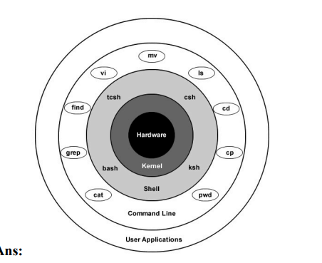

The kernel and shell are the heart and soul of the operating system.The kernel ingests user input

via the shell and accesses the hardware to perform things like memory allocation and file

storage.The shell is an interface that interprets the command line input and calls the necessary

programs to do the work. The commands that you enter are programs themselves, so once the

work is done, the command line will return to a prompt and await further input.There are several

different shells, and syntax and shortcuts vary between them.

5.Advantages of UNIX OS.

● Open Source

● Safe and Protective

● Portability

● Lightweight

● Great Stability

● No Require Anti-virus

● Like as MS-DOS

● Multitasking Nature

● Great Flexibility

6.Disadvantages of UNIX OS.

● Hostile GUI

● Not proper documentation

● Less technical support

● Cryptic commands

● Less user friendly